Rotary Youth Exchange (RYE)
Clara, inbound student from Denmark & Sally an outbound student who went to Taiwan.
Paul, the current inbound student from France.
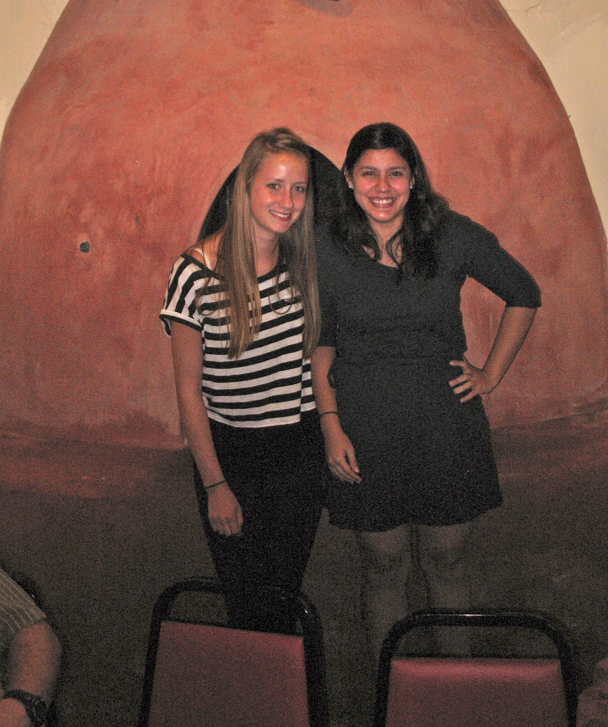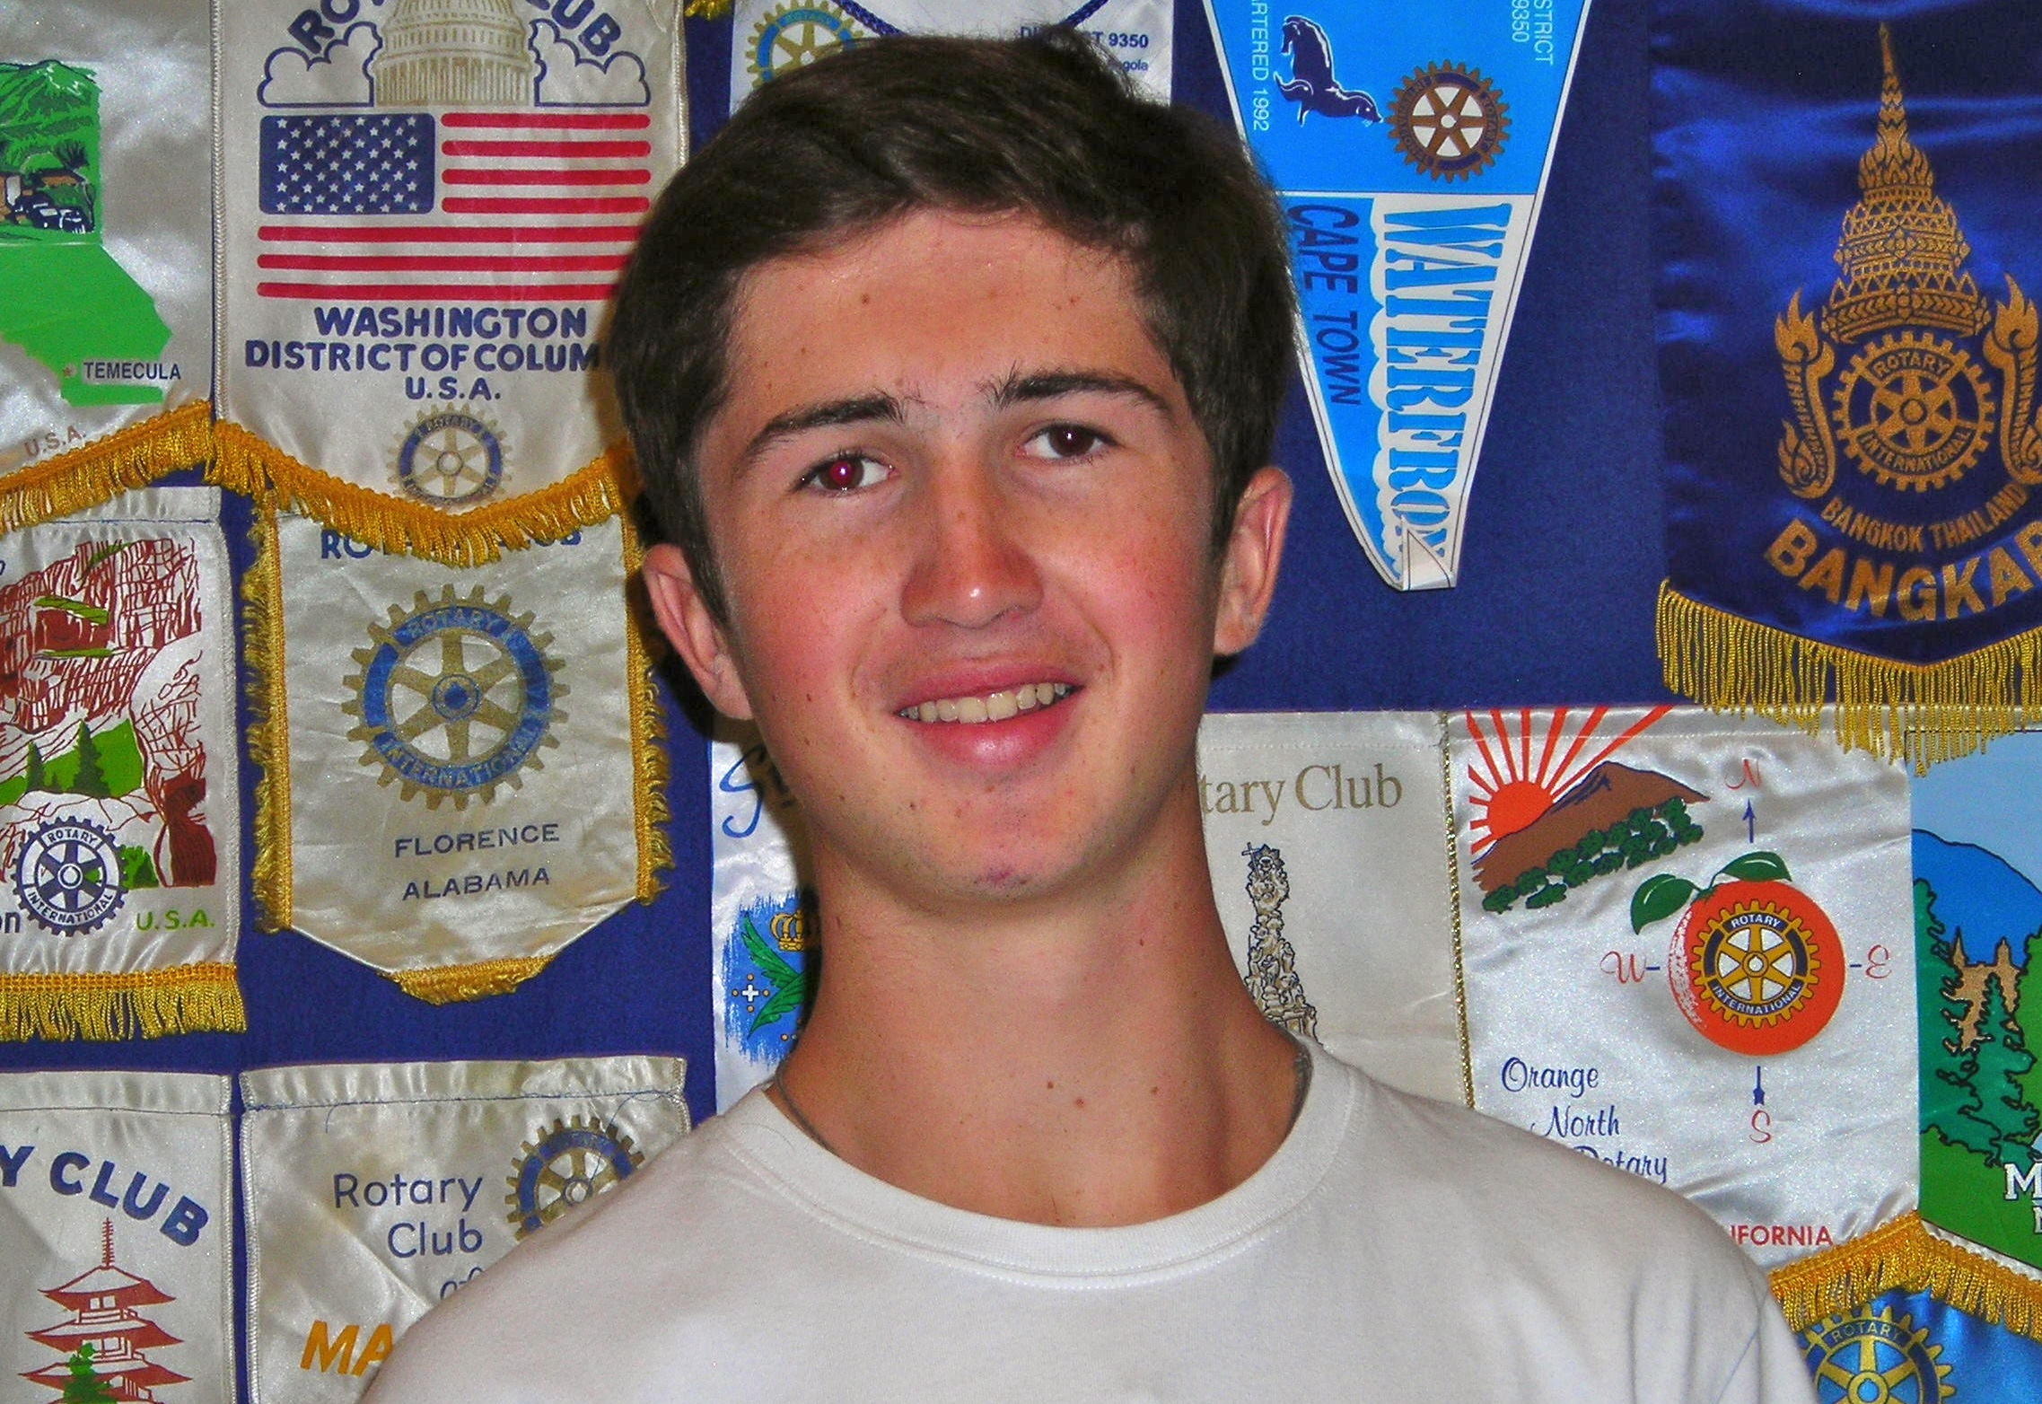
The Rotary Youth Exchange is a youth program placing approximately 8,000 students worldwide each year. Incoming students come from one of eight countries participating with Rotary District 5520. Outbound students are placed in one of the eight countries. It is a country to country program open to high school students from the ages of 14 to 18 ½. It is for one academic year and provides students an opportunity to study in another country and to develop maturity, leadership skills and serve as young ambassadors.

The Las Cruces Rio Grande Rotary Club is always looking for host parents for our incoming students.

